**QUCS AHP-1**

**-Achyuth S.S, Section ‘A’**

**-SRN: PES1UG21EC010**

1. Determine the unknown nodal voltages in the circuit given below. Draw and simulate the given circuit in QUCS and verify your calculation. Submit your calculation and screenshot of the circuit and results observed in QUCS.

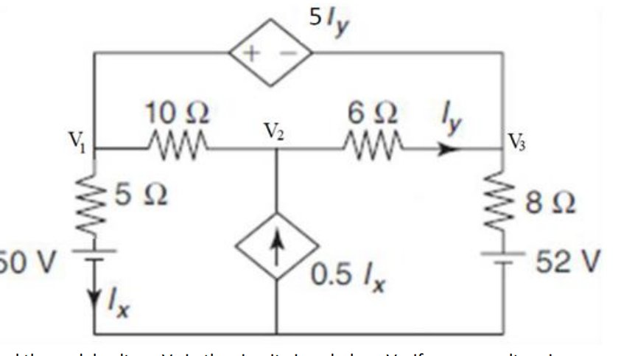

Solution:

Manual:

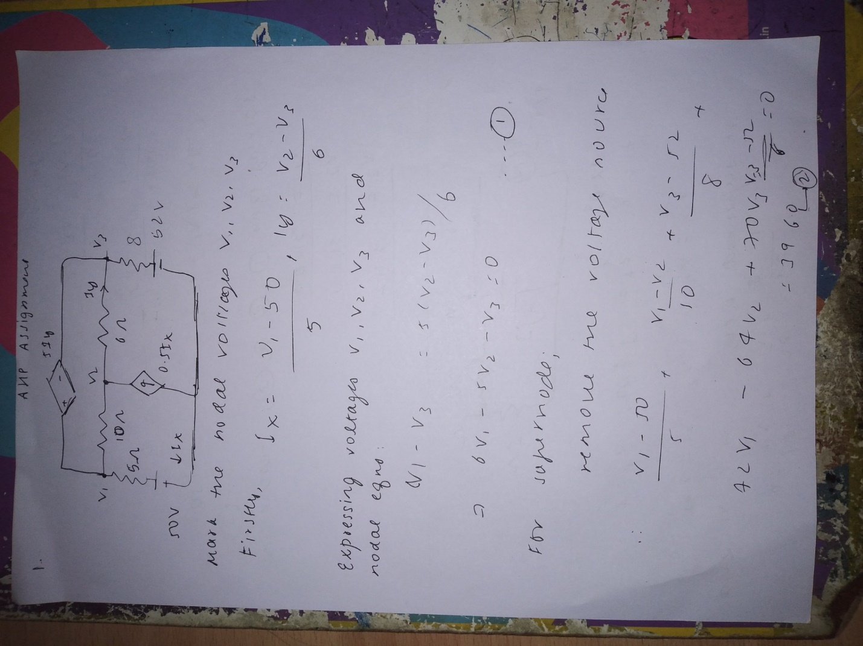

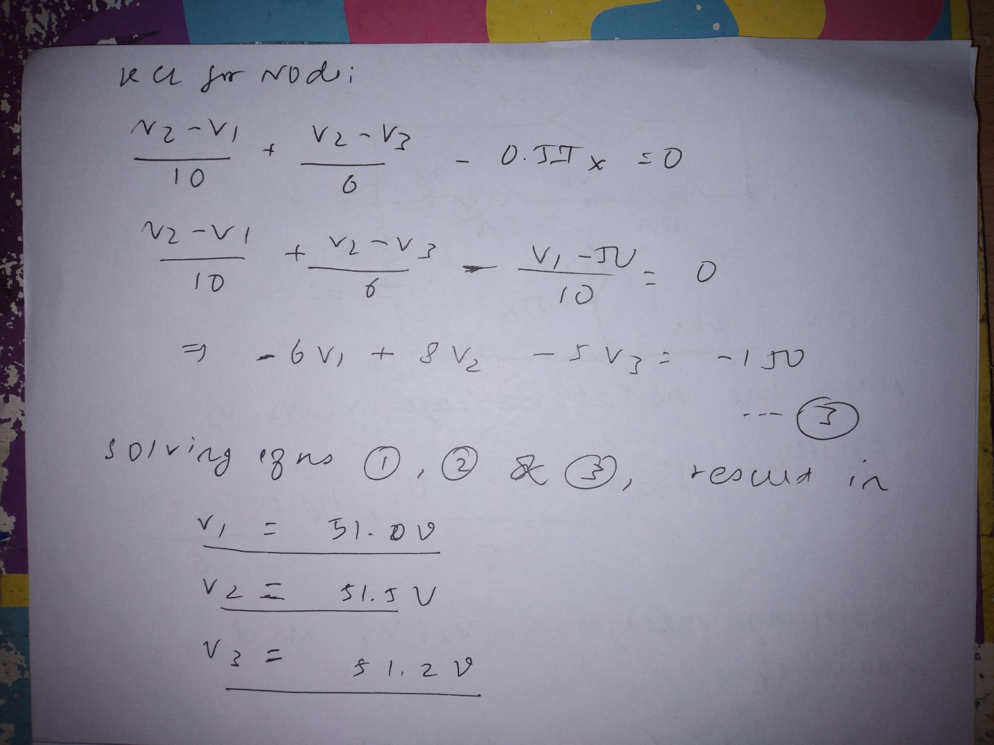

QUCS Solution: 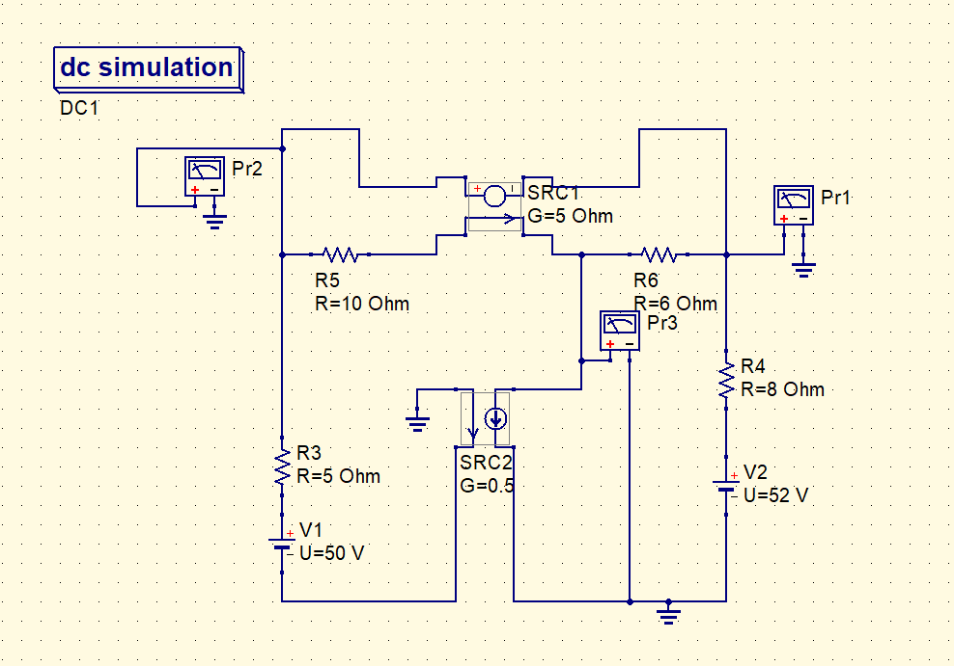

Table:

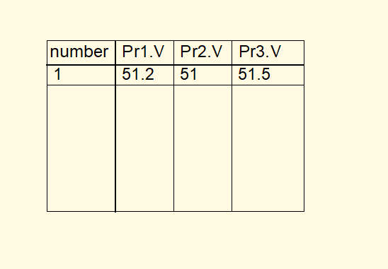

2. Find the nodal voltage Vx in the circuit given below. Verify your results using simulation in QUCS. Submit your calculation and screenshot of the circuit and results observed in QUCS.

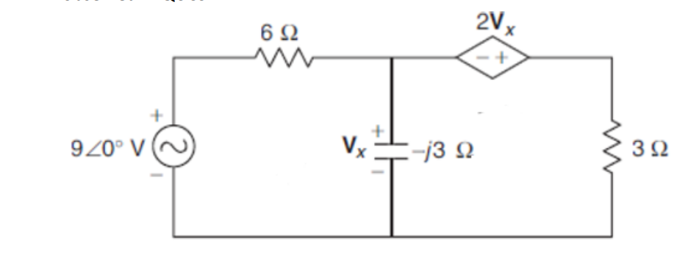

Solution:

Manual:

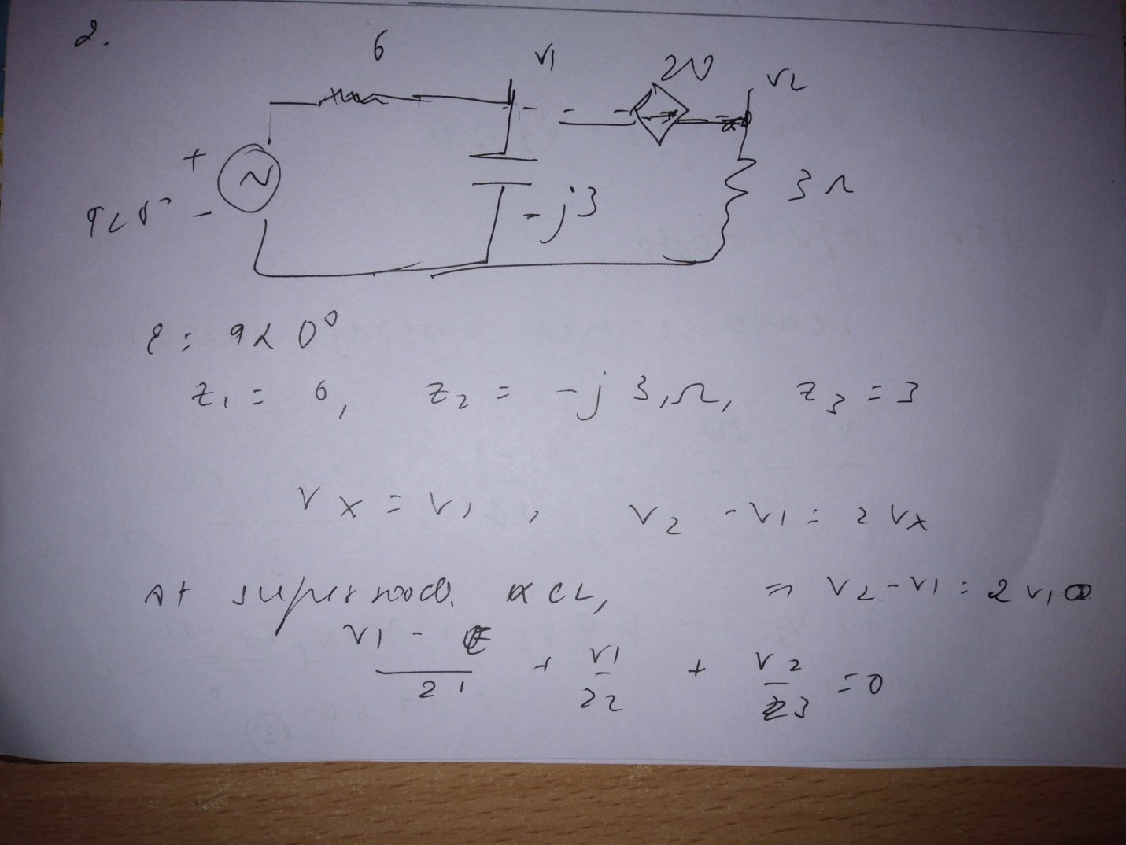

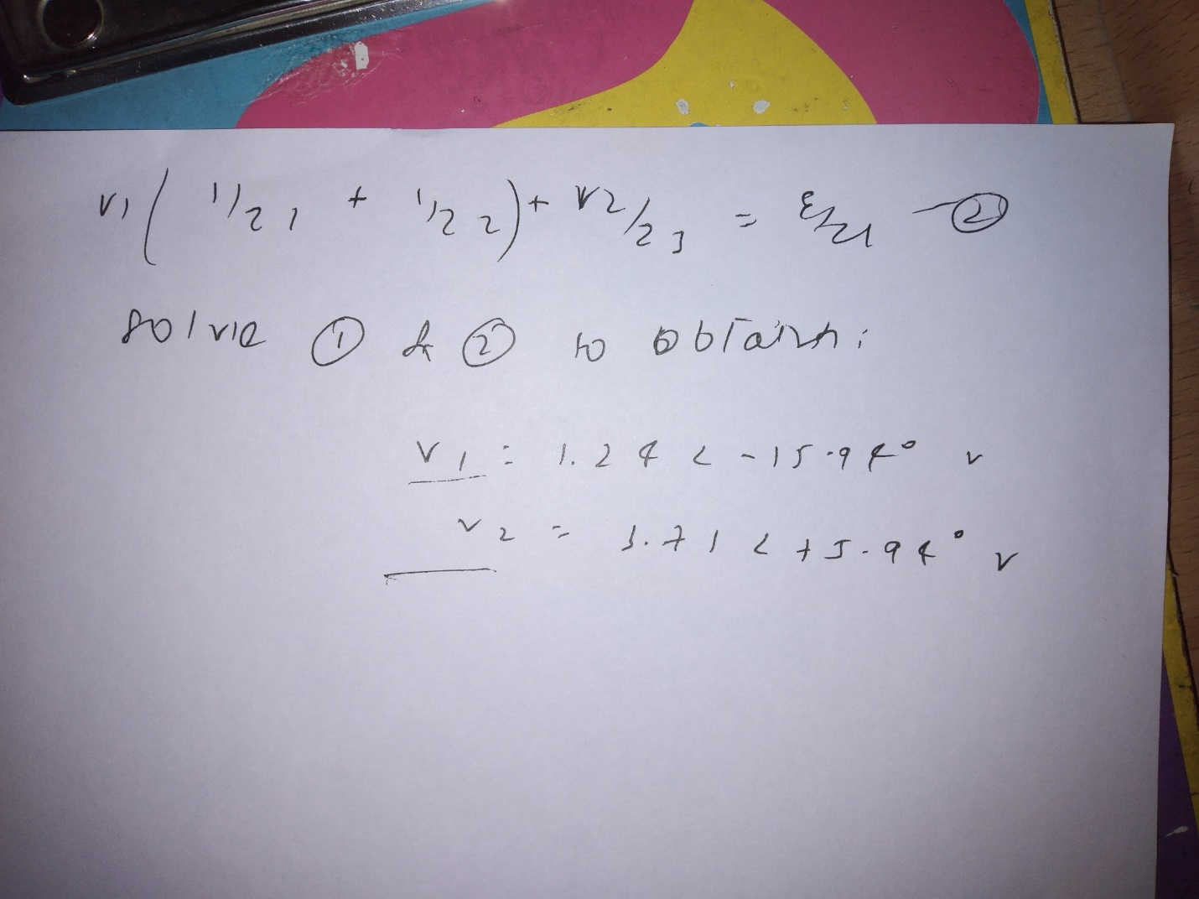

QUCS Solution:

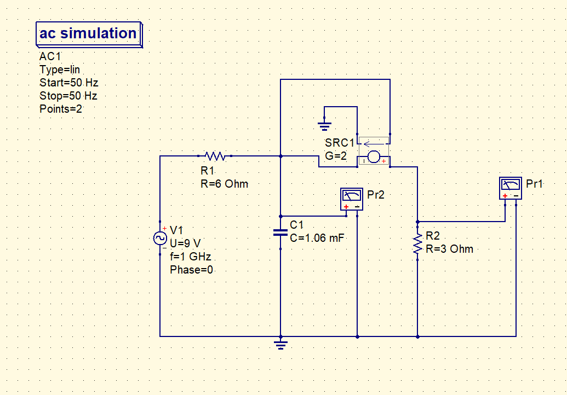

Table:

